Index

Sr. No. | Documentation Section | Page No.
1 | Dashboard | 1–2
2 | Voter Board | 3–4
3 | Members Board | 6–8
4 | Booth Officer Board | 11–12
5 | Booth Board | 13–14
6 | Forms Board | 16–17
7 | AI Calling Board | 19
8 | Profile & Organization | 20–21
9 | Organization Board | 22–23
10 | Operations Board | 26–27
11 | Individual Voter Profile | 28–30
12 | Account Creation / Login | 31

VoterX Client Panel – Dashboard Documentation
1. Dashboard
The Dashboard is the main screen of the VoterX Client Panel. It displays the available voter, member, booth, BLO, organization, gender, caste, and booth-level information for the selected election.
2. Dashboard Header
- Dashboard title with the selected Vidhan Sabha AC.
- Displays the logged-in user.
- Election/Constituency selector available at the top-right.
- Filters button available for filtering the dashboard data.
3. Summary Information
The dashboard displays four summary cards:
- Total Voters – Displays the total number of voters.
- Total Members – Displays the total number of members.
- Total Booths – Displays the total number of booths.
- BLO Officers – Displays the total number of BLO officers.
4. Organisation Score
The Organisation Score section displays:
- Organisation score percentage.
- Booth Coverage percentage.
- Number of booths without voter data.
- Add Voters option.
5. Gender Distribution
The Gender Distribution section displays a chart showing:
- Total voter count.
- Male voter count and percentage.
- Female voter count and percentage.
6. Member Summary
The Member Summary section displays the available member information. When member data is not available, the screen displays “No member data available.”
7. Caste Information
The dashboard contains two caste-related sections:
- Caste Categories – Displays voter counts across the available caste categories.
- Caste Distribution – Displays the distribution of individual caste entries.
8. Top Booths by Voter Count
The Top Booths by Voter Count section displays booths according to voter count, including:
- Booth ranking
- Booth/polling location name
- Voter count
- Booth identifier
- Location/area information
Dashboard Flow
Login → Dashboard → Select Election/Constituency → Apply Filters → View Summary Cards → View Organisation Score & Booth Coverage → View Gender Distribution → View Member Summary → View Caste Information → View Top Booths by Voter Count

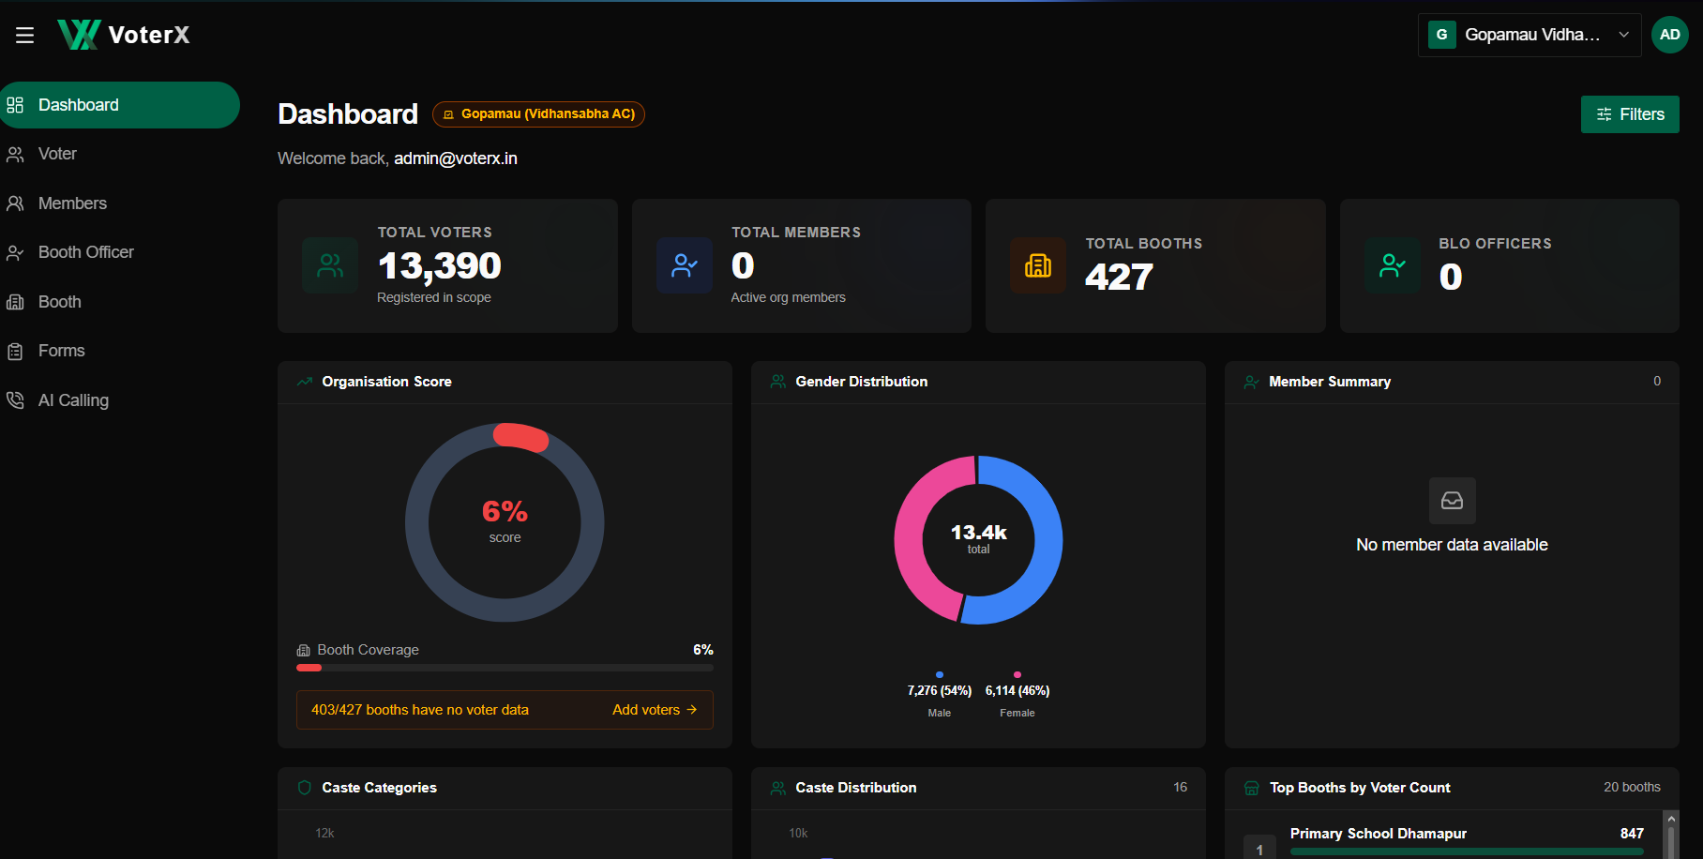

VoterX Client Panel – Voter Board
1. Voter Board
The Voter Board displays all available voter records for the selected election scope. It provides tools to search, filter, view, add, and upload voter data.

2. Search & View
- Search voters using Name or EPIC Number.
- View records in Table View or Cards View.
- Use Hide Filters to hide the filter section.
- The Actions menu provides Upload CSV and Add Voter options.

3. Voter Filters
Voters can be filtered using:
- State
- Lok Sabha
- Vidhan Sabha
- Booth
- Gender
- Age Range
- Caste
These filters help narrow the displayed voter records according to the selected criteria.

4. Voter Information
Table View displays:
- Serial Number
- Name
- EPIC Number
- Gender
- Age
- Caste
- House Number
- Booth
- Village / Section
- Revision
- Status
Cards View provides a compact voter profile showing:
- Name and EPIC Number
- Gender and Age
- Caste
- Booth information
- House Number
- View Details option

5. Add New Voter
The Add Voter option opens a four-step registration form:
Identity → Profile → Occupation → Political Interest
The Identity section includes fields such as EPIC Number, Booth Number, Name, Gender, Marital Status, Date of Birth, Relation details, Caste, and Caste Category.
Create & Next is used to proceed through the registration steps.

6. Upload Voter Data
The Upload CSV option allows voter records to be added through a CSV file from the Actions menu.
Voter Board Flow
Voter → Search / Apply Filters → View Voter Records → Table / Cards View → View Details
Add Voter:
Voter → Actions → Add Voter → Identity → Profile → Occupation → Political Interest → Create
Upload Voter Data:
Voter → Actions → Upload CSV → Upload Data
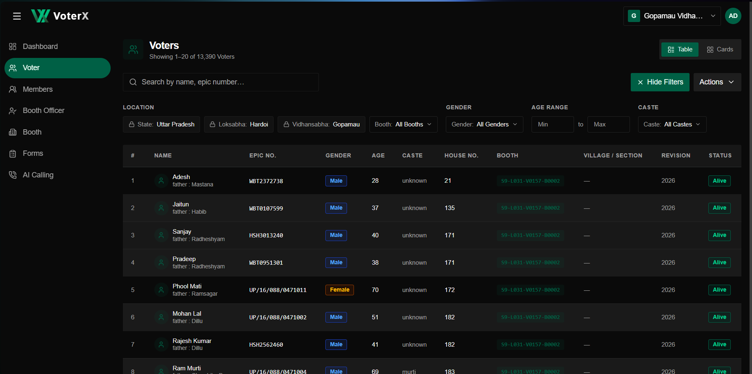
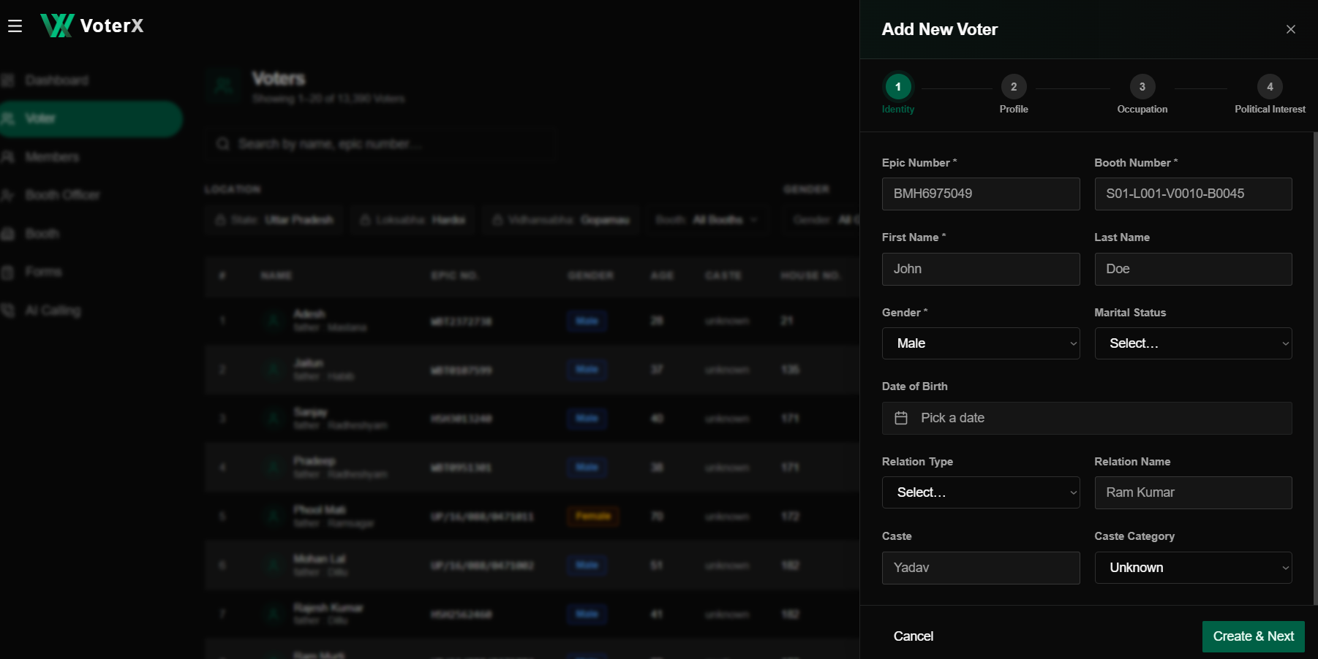

VoterX Client Panel – Members Board
1. Members Board
The Members Board displays the available organization/member records. It provides options to search, filter, view, register, add, and upload members.

2. Search & View
- Search members using Name or Mobile Number.
- View members in Table View or Cards View.
- Filters can be used to narrow the member records.
- The Actions menu provides:
  - Registrations
  - Create Link
  - Add Member
  - Upload CSV

3. Member Information
The Members table displays:
- Serial Number
- Name
- Mobile
- Email
- Member Type
- Constituency
- Join Date

4. Member Registration
The Registrations option opens the registration management page, which displays:
- Total registrations
- Pending registrations
- Approved registrations
- Rejected registrations
It also provides:
- Search by Name or Mobile
- Registration status filter
- Registration records with Name, Mobile, Member Type, Submitted date, Status, and Actions

5. Add New Member
The Add Member option opens a multi-step member registration form:
Identity → Address → Profile → Occupation → Political
The Identity section includes:
- First Name
- Last Name
- Mobile Number
- Member Type
- Gender
- Date of Birth
- Marital Status
- Caste
- Caste Category
- Relation Type
- Relation Name
The Next button is used to continue through the registration steps.
6. Upload Members CSV
The Upload CSV option allows members to be imported using a CSV file.
The upload window specifies:
- Required columns: first_name, mobile_number
- Other member fields are optional.
- Key issues can use pipe-separated values.
- Mobile number must be unique and 10 digits.
- A Template can be downloaded for the required CSV format.

7. Create Member Registration Link
The Create Link option generates a registration form link that can be shared with members.
The registration-link window provides:
- Active registration link
- Link expiry date
- Copy option
- QR Code
- Download QR Code
- Deactivate option
The generated link can therefore be shared directly or through the QR code for member registration.
Members Board Flow
Members → Search / Filters → View Members → Table / Cards View
Add Member:
Members → Actions → Add Member → Identity → Address → Profile → Occupation → Political → Submit
Registration:
Members → Actions → Registrations → Search / Filter → View Registration Status
Create Link:
Members → Actions → Create Link → Generate Registration Link → Copy / QR Code → Share
Upload Members:
Members → Actions → Upload CSV → Select CSV → Upload Members

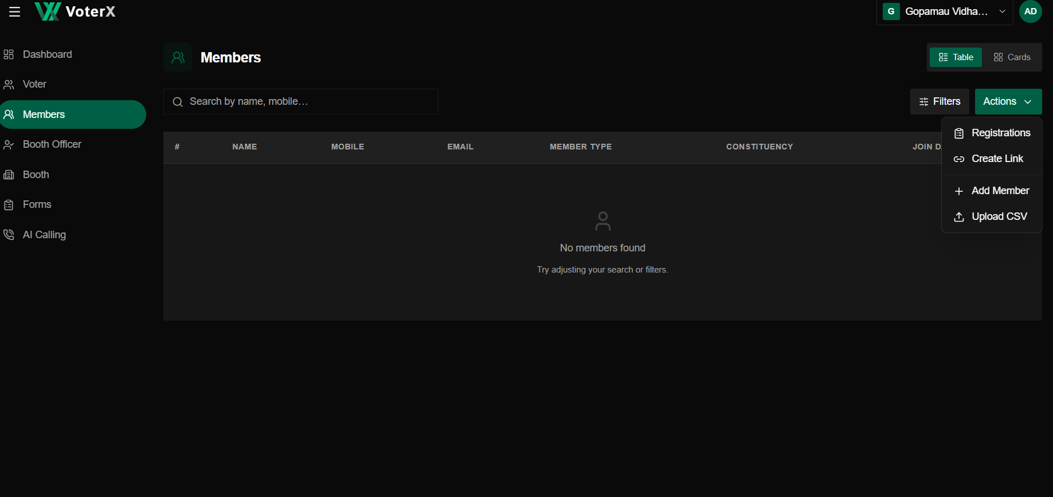

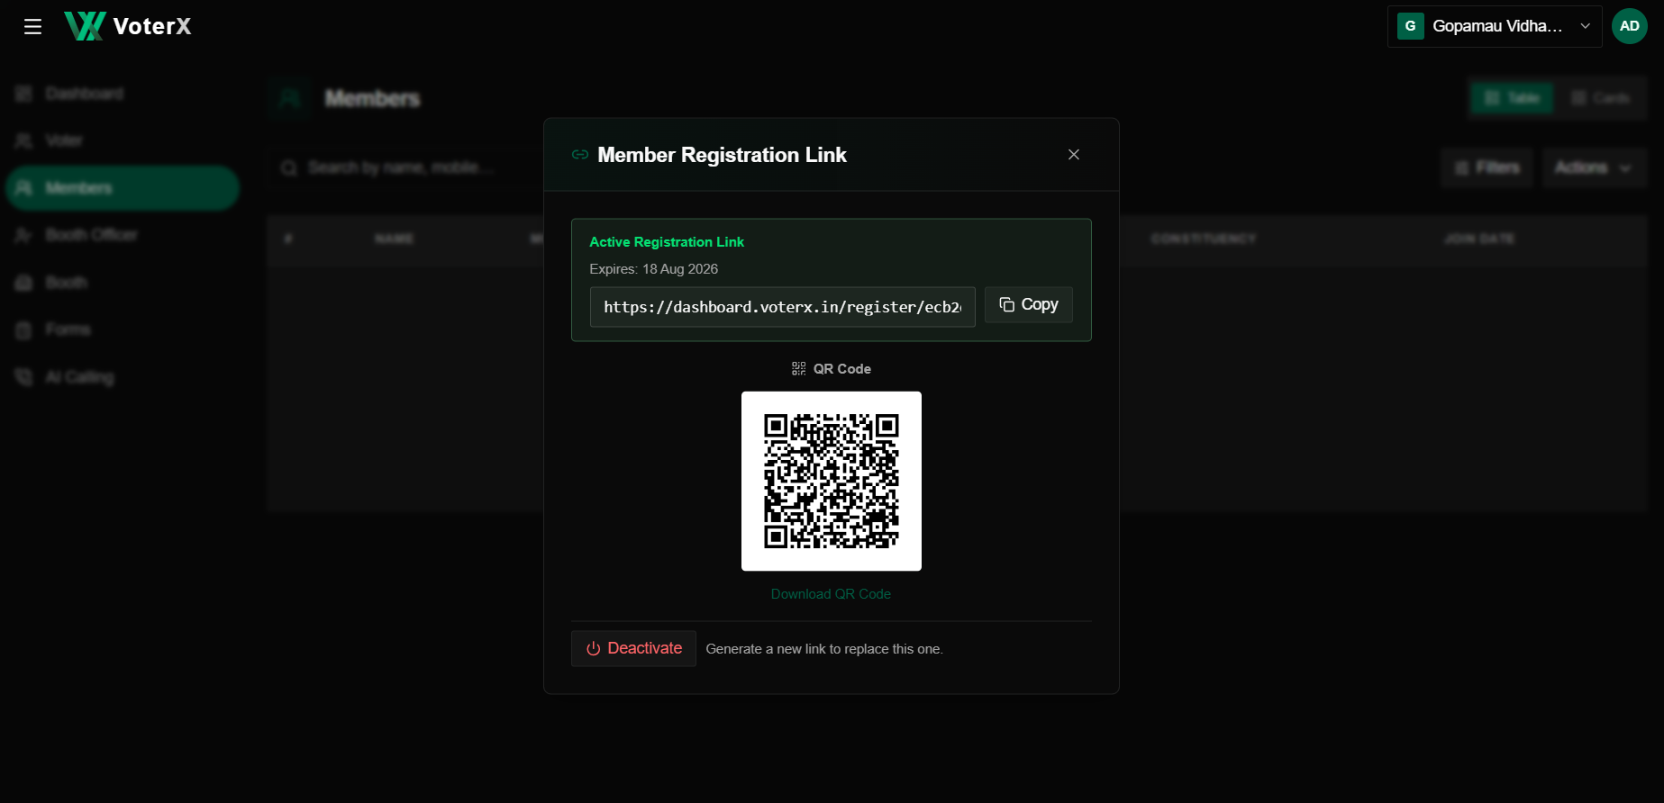
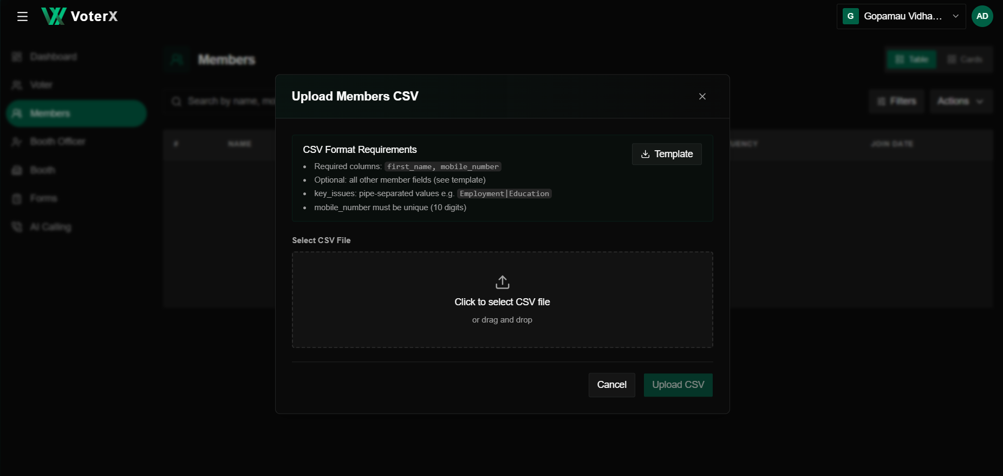

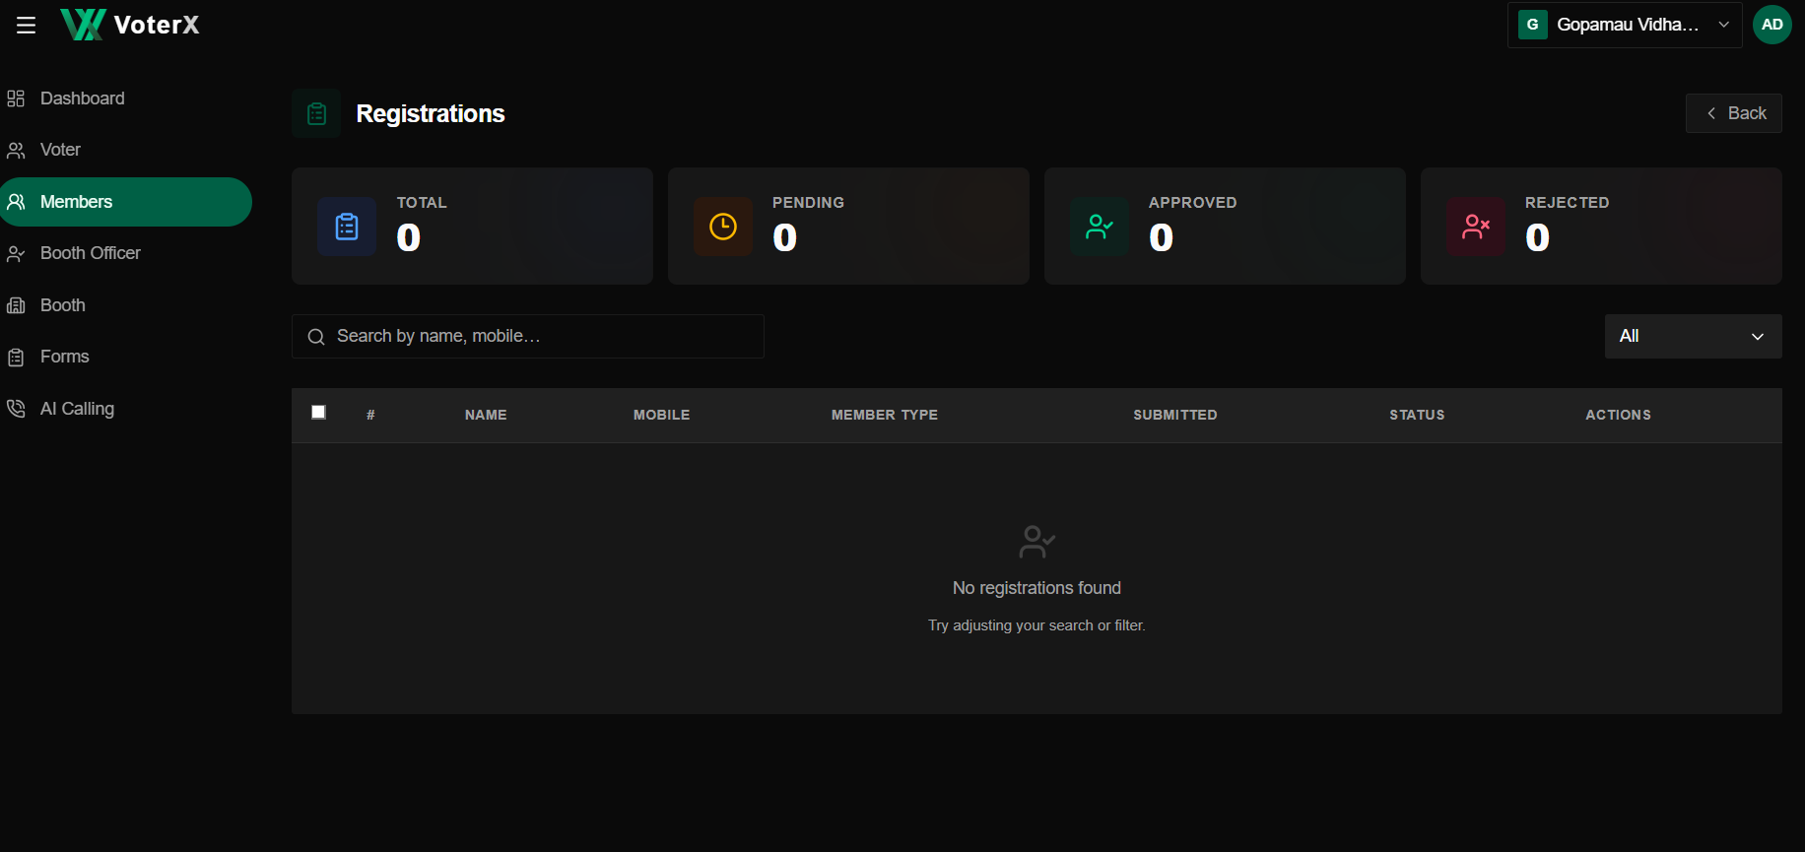

VoterX Client Panel – Booth Officer Board
1. Booth Officer Board
The Booth Level Officers (BLO) section is used to view and manage available Booth Officer records. It provides a searchable list with Table and Cards views, along with an option to add a new BLO.

2. Search & View
- Search: Find officers using Name or Designation.
- Table View: Displays BLO information in a structured table.
- Cards View: Provides an alternative card-based view of the records.
- Add BLO: Opens the form to create a new Booth Officer record.

3. BLO Information
The table displays the following details for each officer:
- Name
- Designation
- Booth
- Vidhan Sabha (AC)
- Lok Sabha (LC)
- State
- Source
- Action
When there are no records, the board displays “No BLOs found.”

4. Add Booth Officer
The Add Booth Officer form is divided into two steps:
Officer Details → Location
The Officer Details step captures:
- Full Name
- Designation
- Phone Number
The Next button moves the user to the Location step, where the officer's location details are entered.
Booth Officer Flow
Booth Officer → Search / View Records → Table / Cards View
Add New BLO:
Booth Officer → Add BLO → Officer Details → Next → Location → Submit

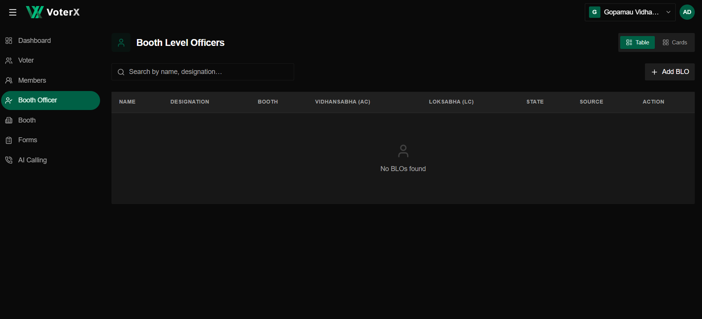

VoterX Client Panel – Booth Board
1. Booth Board
The Booth section displays the available booths for the selected election scope. It provides a searchable list of booths and allows the user to switch between Table and Cards views.

2. Search & View
- Search Booths: Search for a specific booth from the available booth list.
- Table View: Displays booth information in a structured table.
- Cards View: Provides an alternative card-based view.
- The board shows the number of booths currently displayed and the total booth count.

3. Booth Information
The booth list displays:
- Booth No.
- Building
- Village
- Block
- District
- Vidhan Sabha / Lok Sabha
- Total Voters
- Action option for each booth.

4. Booth Actions
The Actions menu provides:
- Add Booth – Create a new booth record.
- Import CSV – Import booth data through a CSV file.
Each booth also has an individual Action option for accessing its available operations/details.

5. Booth Details
Selecting a booth opens its detailed view. The booth detail page contains three sections:
- Insight – Displays booth-level analytics.
- Voters – Provides voter information for the selected booth.
- Documents – Provides documents associated with the booth.
The Insight section displays:
- Voter distribution by gender.
- Caste distribution.
- Caste category distribution.
- Officer information.
- Booth information, including building, location, village, panchayat, block, and district.
- A map/location view of the booth.
- Compare voters with e-roll PDF option.
- Booth information accuracy warning with View Details and Resolve Issue options when checks require review.
Booth Flow
Booth → Search / Select Booth → View Booth List → Select Booth → Booth Details
Booth Details:
Insight → Voters → Documents
Booth Management:
Booth → Actions → Add Booth / Import CSV
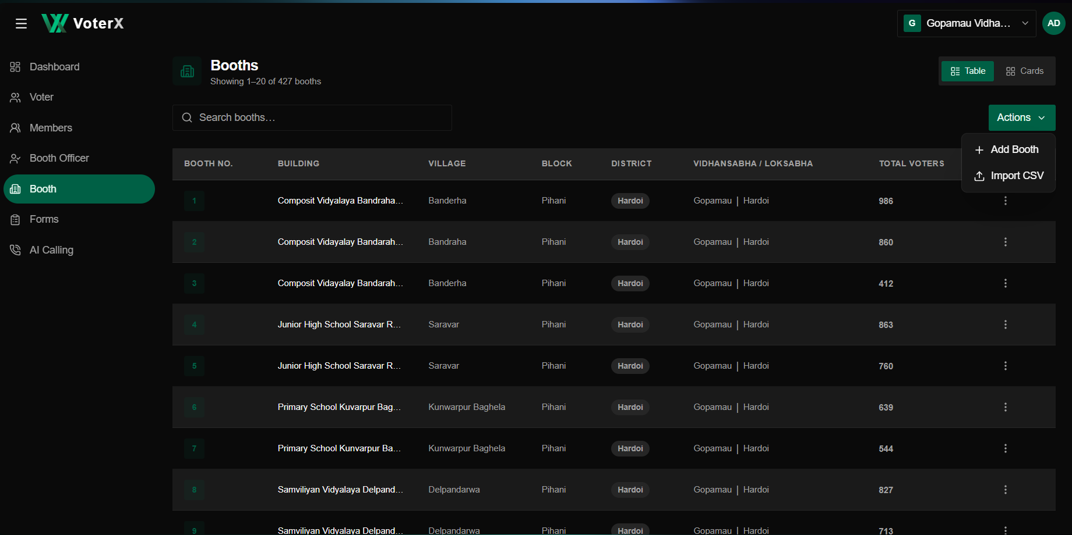
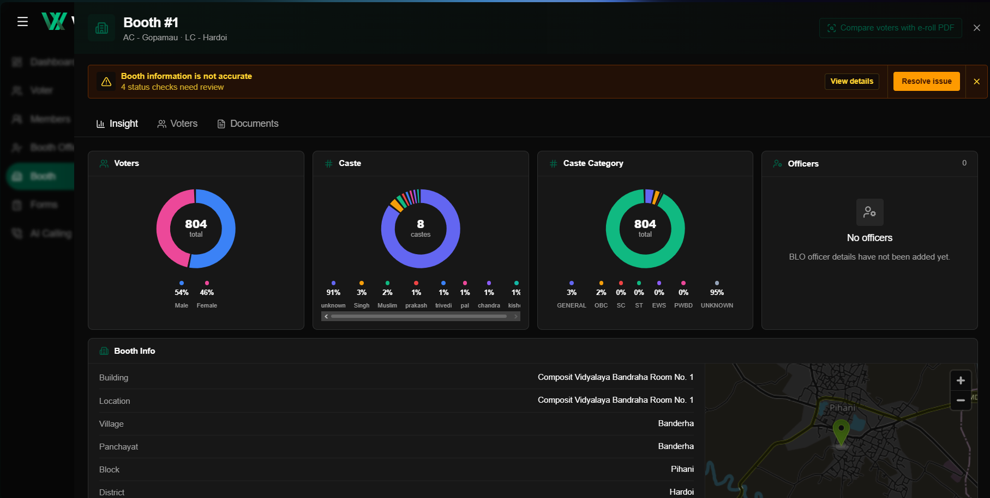

VoterX Client Panel – Forms Board
1. Forms Board
The Forms section is used to manage existing forms, create new forms, and view form analytics. The board provides a search bar and displays each form with its Title, Audience, Status, Responses, Created Date, and Actions.
2. Form List
Each form record shows:
- Title – Name of the form.
- Audience – Who can participate.
- Status – Draft or Active.
- Responses – Number of submitted responses.
- Created – Form creation date.
- Action – Options for managing the form.
3. Create New Form
The New Form option opens a two-step process:
Basic Details → Form Section
Basic Details includes:
- Form Title
- Description
- Participant Type: All, Public, Voters, or Members.
- Status: Draft, Active, or Closed.
Save & Next moves the form to the next section for adding form questions/sections.
4. Form Analytics
Selecting an existing form opens its analytics page with:
- Total Responses – Total number of respondents.
- Responses Over Time – Shows the daily submission trend.
- By Respondent Type – Shows responses based on respondent type.
- Questions – Displays the questions included in the form and the response count for each question.
The displayed form contains 26 questions, including respondent information such as name, father's name, village/tole and booth number, mobile number, age, and gender, followed by questions covering social groups, major booth/area problems, development conditions, political discussions, local influential people, election issues, voter preferences, political parties, leaders, women’s opinions, and other active leaders.
5. Form Management
The existing form page also provides:
- Analytics – View response statistics and question-wise responses.
- Responses – Access submitted responses.
- Edit Fields – Modify form fields.
- Access – Manage form access.
- Share – Share the form with respondents.
Form Flow
Forms → Search / Select Form → View Form Details
Create Form:
Forms → New Form → Basic Details → Form Section → Save
Existing Form:
Forms → Select Form → Analytics / Responses → View Question-wise Responses
Form Management:
Edit Fields / Access / Share

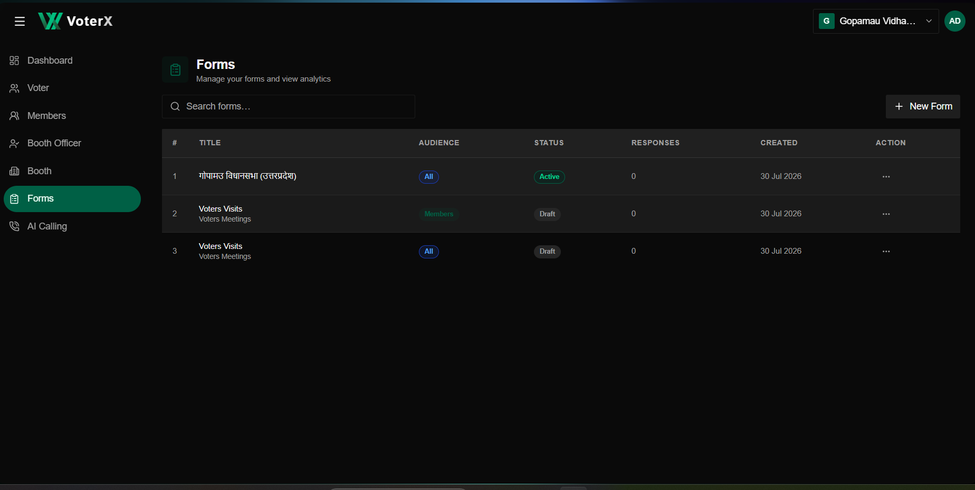

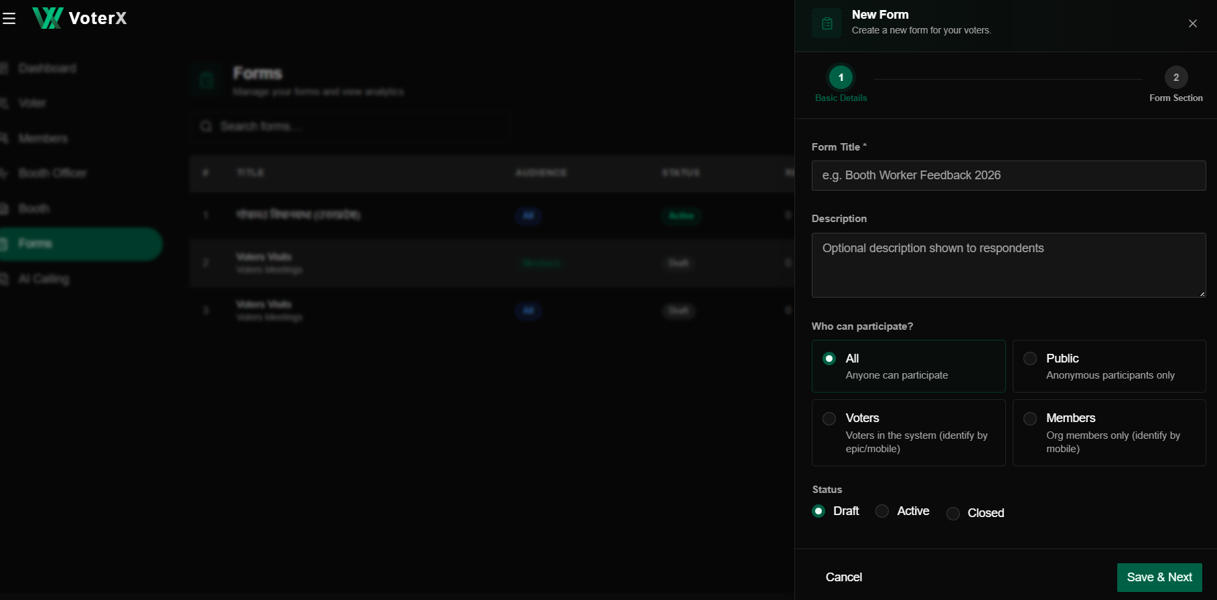

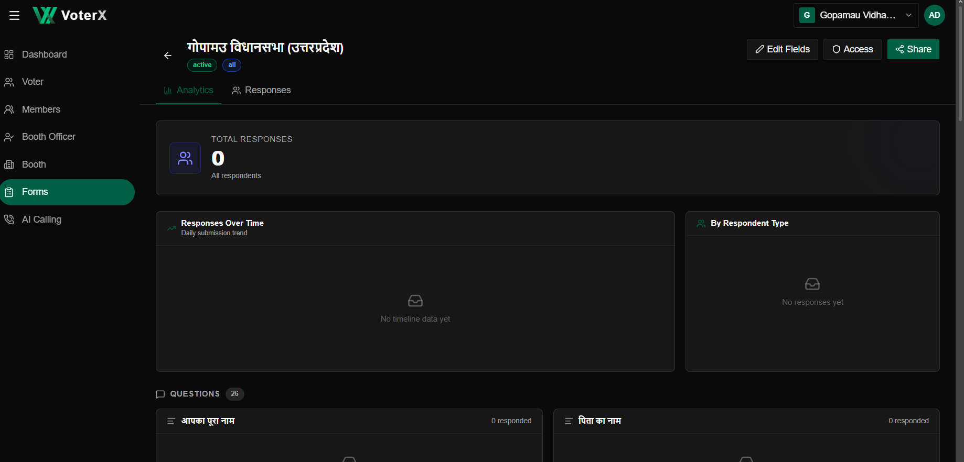

VoterX Client Panel – AI Calling Board
1. AI Calling
The AI Calling section is designed to manage AI calling workspaces and campaigns. The current screen provides navigation options for Analytics, Campaigns, Assistants, Call History, Number, and Workspace.
2. Workspace
The currently displayed Workspace section allows the organization to connect RinggAI for AI calling.
The workspace setup includes:
- Workspace Name – Name of the calling workspace.
- RinggAI API Key – API key required to connect RinggAI.
- Description – Optional notes for the workspace.
- Create Workspace – Creates the workspace after entering the required details.
The screen also states that the API key is saved securely and used to fetch workspace credits.
AI Calling Flow
AI Calling → Workspace → Enter Workspace Details → RinggAI API Key → Create Workspace
Note:
The Analytics, Campaigns, Assistants, Call History, Number, and Workspace navigation buttons are visible on the screen. However, their individual functionality is not demonstrated in the provided screen, so no additional functionality is documented here.
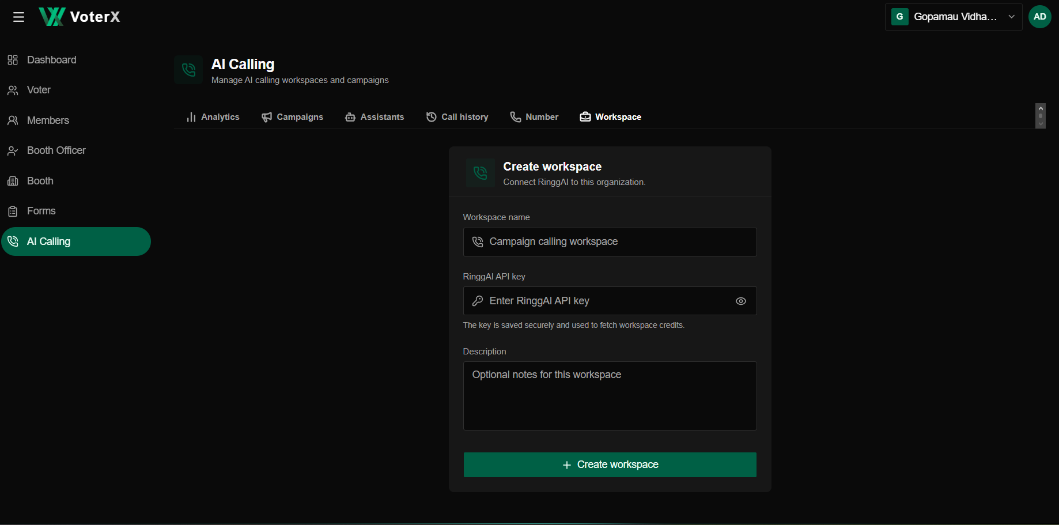
VoterX Client Panel – Profile & Organization
1. Profile
The Profile option is available from the top-right account menu. It displays the user's account details and organization memberships.
2. Account Details
The profile page displays:
- Profile Name
- Email Address and verification status
- Join Date
- User ID
- Number of Organizations associated with the account
3. Organizations
The Organizations section lists the organizations associated with the account, along with:
- Organization Name
- Joined Date
- User Role, such as Owner
A Manage option is available for organization management.
4. Organization Switcher
The top-right account menu also provides an organization switcher, showing the organizations available to the user.
The menu includes:
- Current organization
- Other available organizations
- Organization role
- New Organization option
Selecting an organization allows the user to switch between available organizations.
Profile Flow
Top-Right Account Menu → Profile → View Account Details / Organizations
Organization Switch:
Top-Right Account Menu → Select Organization → Switch Organization
New Organization:
Top-Right Account Menu → New Organization
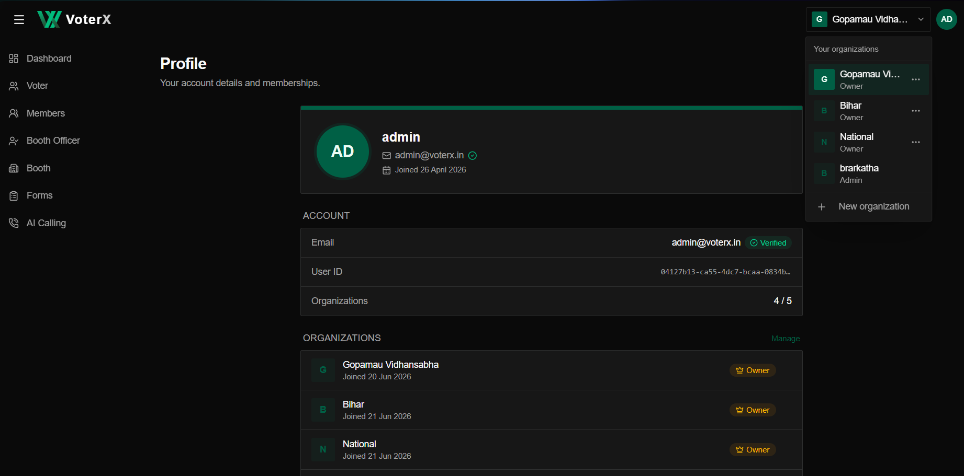

VoterX Client Panel – Organization Board
1. Organization Board
The Organizations section manages the organizations associated with the account. The board displays the organization name, status, role, and creation/join date, with options to view details, edit, and create a new organization.
2. Organization List
Each organization card displays:
- Organization Name
- Status such as Active
- Party
- Role such as Owner or Admin
- Date
- Details – View organization information
- Edit – Edit organization details where available
The board also shows the number of organizations currently used out of the available organization limit.
3. Organization Details
Selecting an organization opens its management page with three sections:
Members → My Access → Permissions
Members displays the organization's members, their roles, joining dates, and an Invite option. Pending invitations are also displayed.
My Access shows the current user's:
- Role
- Joined date
- Invited by
- Scope
- Page access
- Feature access
Permissions displays what each role can do within the organization, including:
- View organization
- Invite members
- Edit organization
- Manage roles
- Delete organization
- Edit data
- Export data
Permissions are shown for Owner, Admin, Editor, and Viewer roles.
4. Create New Organization
The New Organization button opens a two-step setup:
Org Details → Scope
The first step captures:
- Organization Name
- Street
- City
- District
- State
- Country
- Pincode
- Party (optional)
Next proceeds to the Scope step.
Organization Flow
Organizations → View Organization / Edit Organization / New Organization
View:
Organizations → Select Organization → Members / My Access / Permissions
Create:
New Organization → Org Details → Next → Scope → Create Organization
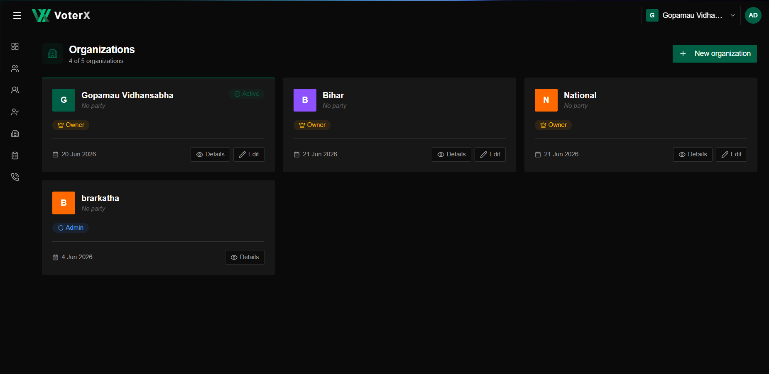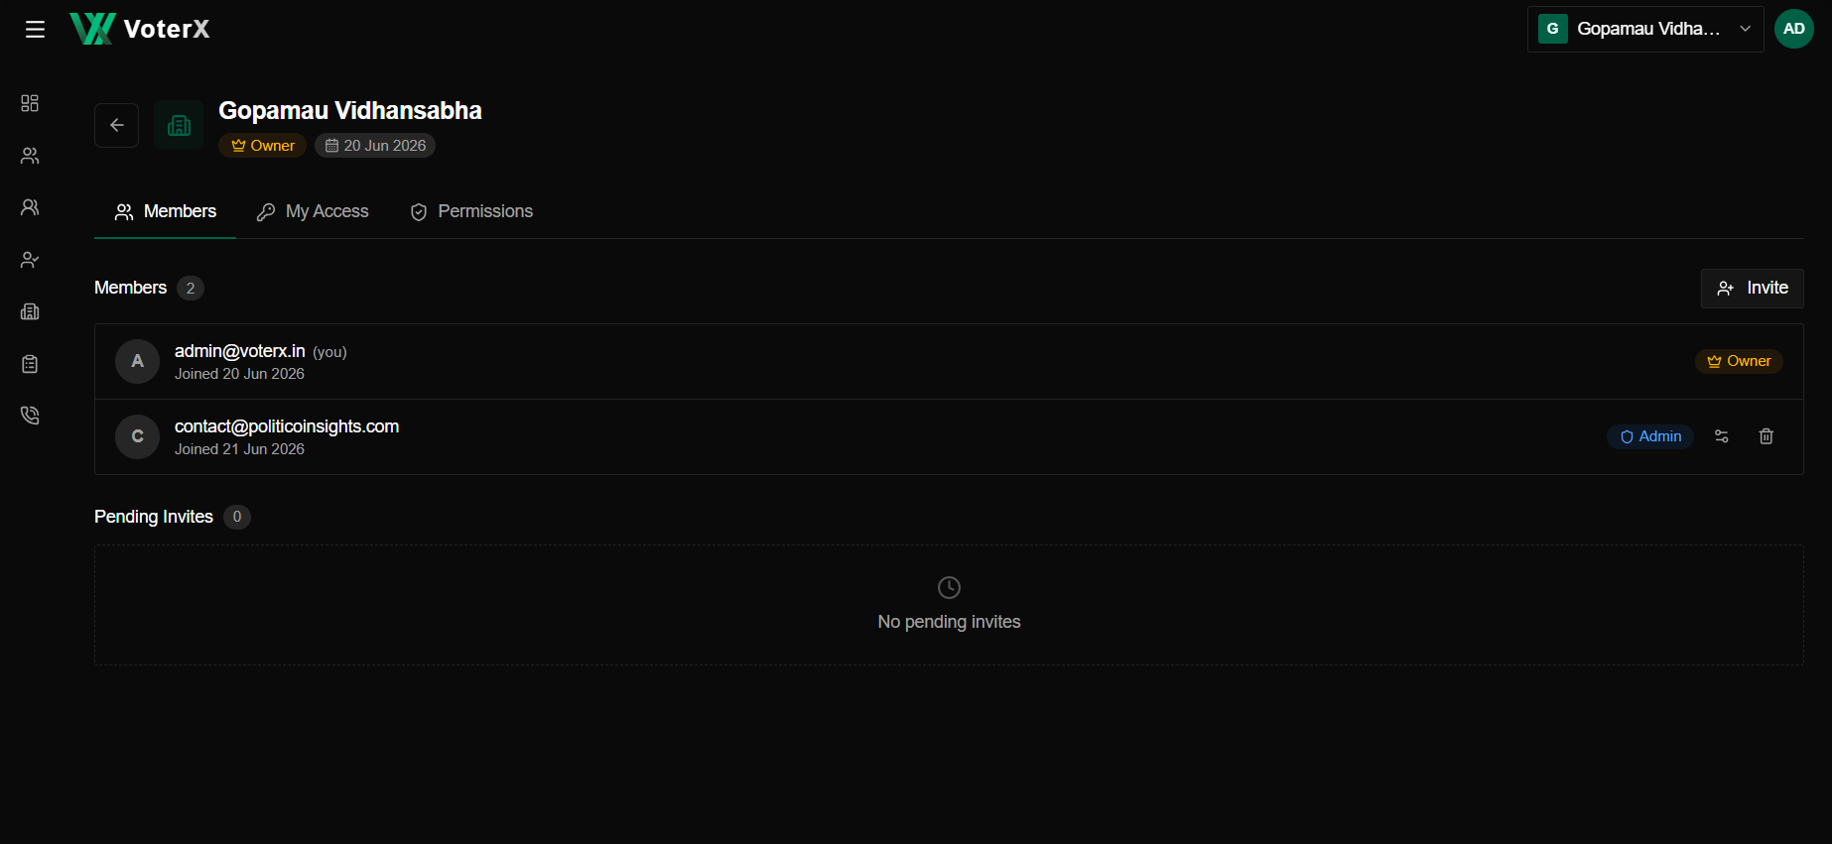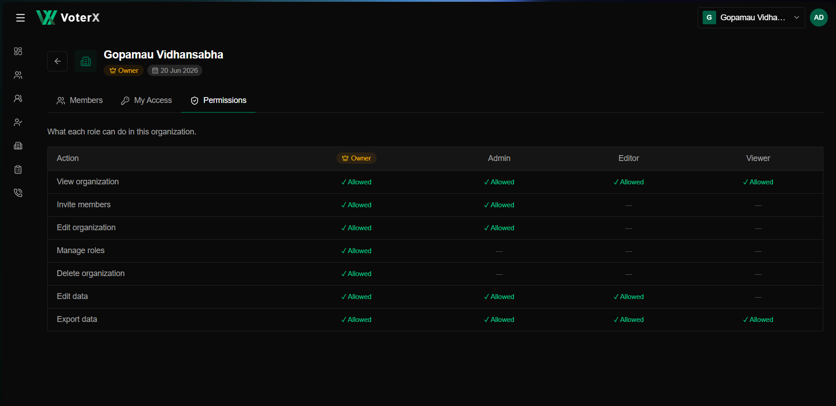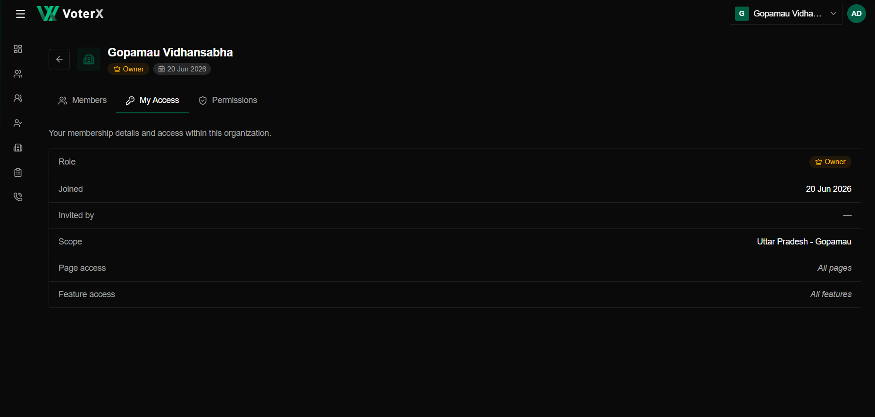

VoterX Client Panel -Operations Board
1. Operations
The Operations option is available from the top-right organization/account menu. It provides access to internal VoterX operational tools and workflows.
2.Operations Board
The board contains the following modules:
Module | Purpose | Current Status
Jobs | Manage OCR imports and voter-PDF processing jobs. | ❌ Not Working
OCR | Upload voter PDFs and review extracted booth and voter data. | ✅ Working
Vidhan Sabha Management | Browse, search, and edit assembly constituencies. | ❌ Not Working
User Management | Support users and review internal access requests. | ❌ Not Working / Coming Soon
System Activity | Monitor platform activity and operational events. | ❌ Not Working / Coming Soon
Quality Checks | Track reviews and outstanding operational tasks. | ❌ Not Working / Coming Soon

3. OCR Workspace
The OCR module is currently functional and provides a PDF extraction workflow with:
- Voter List Language selection
- State selection
- Lok Sabha (PC) selection
- Vidhan Sabha (AC) selection
- Booth / Village selection
- PDF upload / drag-and-drop
- Next option to proceed with processing
Operations Flow
Top-Right Account/Organization Menu → Operations → Select Required Module
OCR Flow:
Operations → OCR → Open Workspace → Select Voter List Details → Upload PDF → Next
Other Modules:
Operations → Jobs / Vidhan Sabha Management / User Management / System Activity / Quality Checks
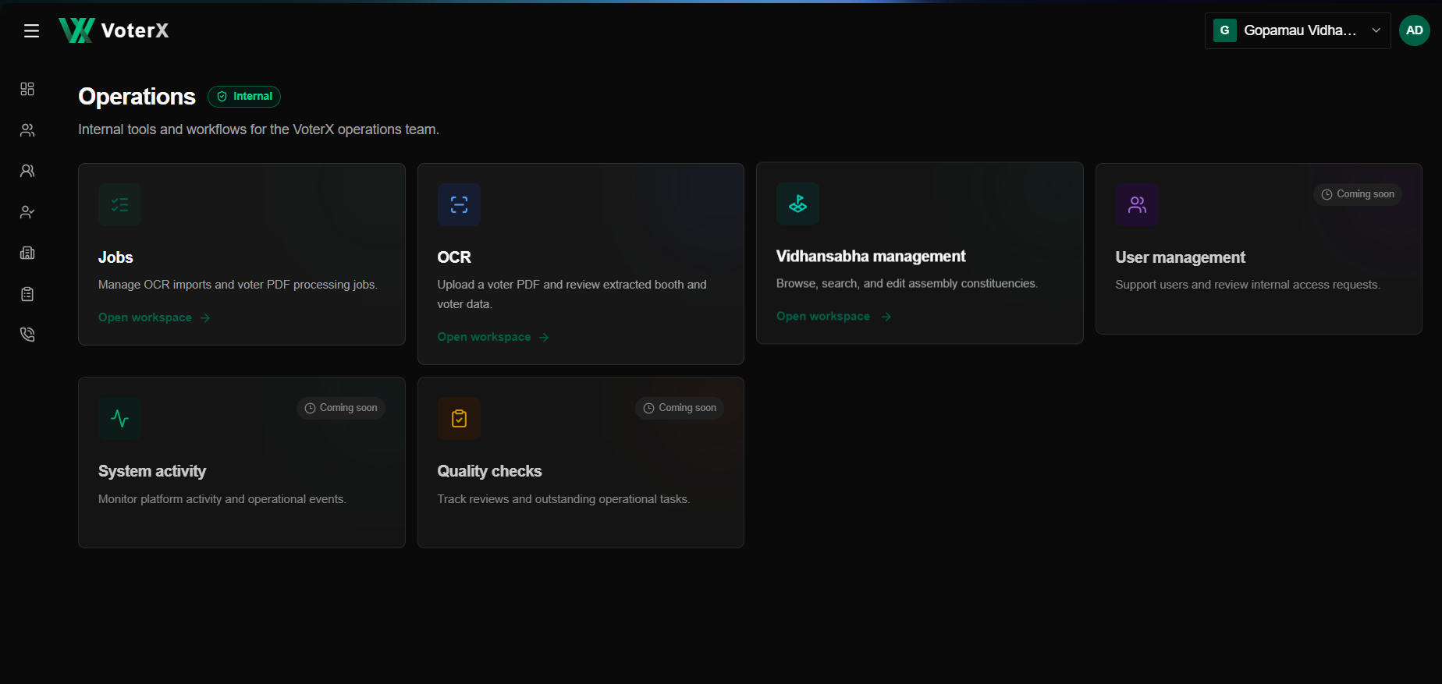

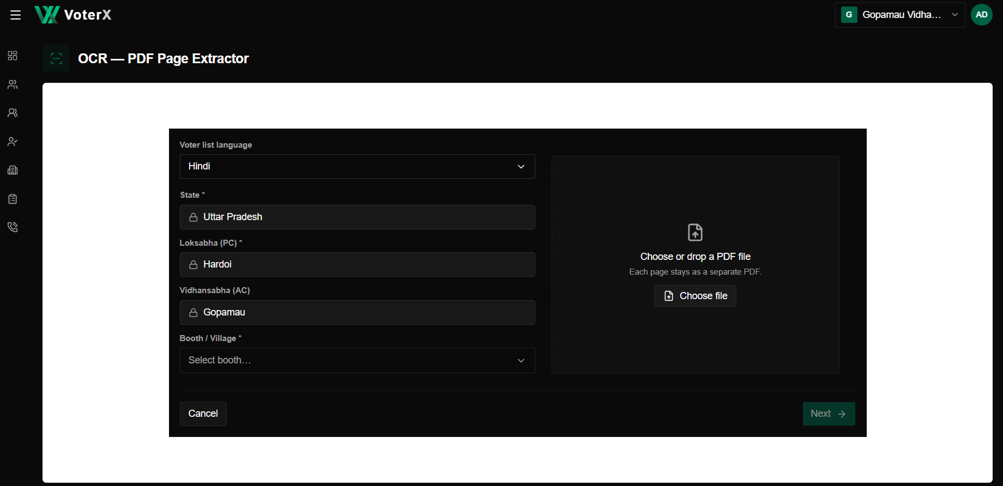

VoterX Client Panel – Individual Voter Profile
1. Voter Details
Clicking on an individual voter from the voter list opens the voter’s detailed profile page.
The profile header displays:
- Voter Name
- Gender
- Voter Status – Alive
- Current Age
- Revision Year
- Edit option
- Delete option
- Close (X) option
2. Identity
The Identity section displays the voter's basic identification details:
- Full Name
- EPIC No.
- Gender
- Marital Status
- Current Age
- Father's Name
- Caste
3. Profile
The Profile section contains contact and identification information:
- Mobile
- Alternate Mobile
- WhatsApp
- Email
- Aadhaar
- PAN
- Issues
4. Occupation
The Occupation section contains:
- Industry
- Employment
- Education
- Income Range
- Communication Preference
5. Political Interest
The Political Interest section contains:
- Interest Level
- Affiliation
- Support
- Influence
- Personality
6. Address
The Address section displays the voter's residential/location details, including:
- House No.
- Village / Section
- Additional address information where available.
7. Actions
The voter profile provides the following actions:
- Edit – Update the voter's available information.
- Delete – Remove the voter record.
- Close (X) – Exit the individual voter profile.

Voter Profile Flow
Voter → Select Individual Voter → Voter Profile → View Identity / Profile / Occupation / Political Interest / Address
Edit Flow:
Individual Voter → Edit → Update Details
Delete Flow:
Individual Voter → Delete → Confirm Deletion
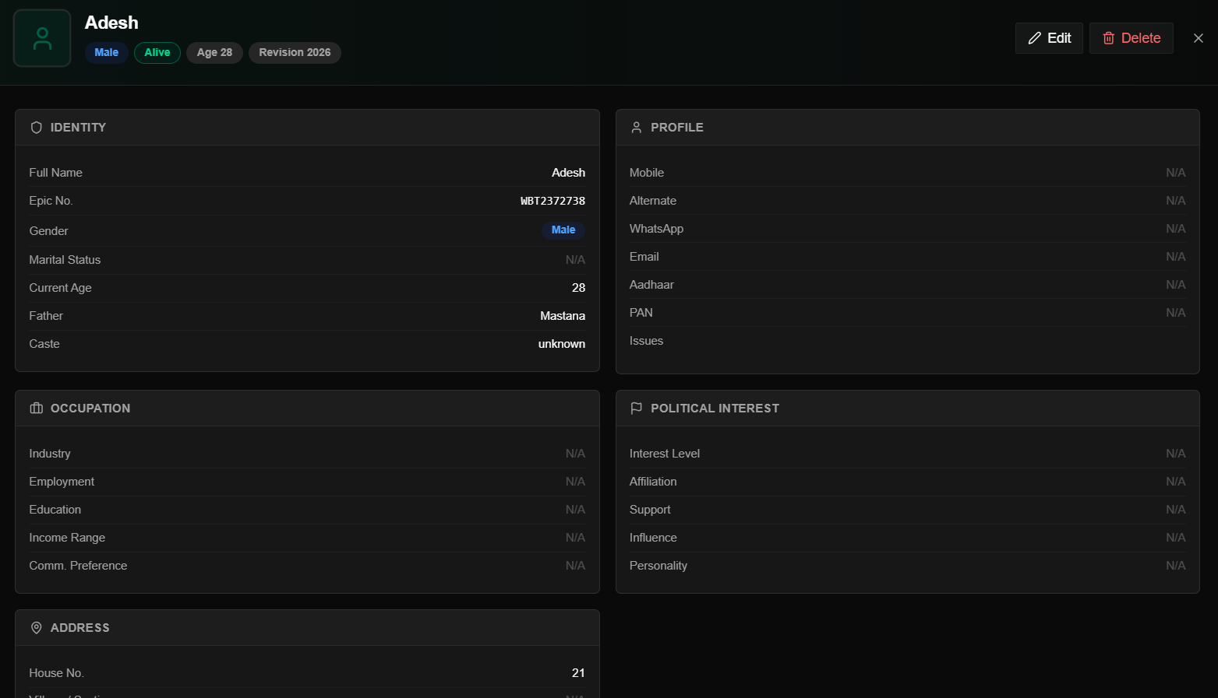

VoterX Client Panel – Account Creation / Login
1. Create Account
The Create Account page allows a new user to register for VoterX and access the platform.
2. Registration Details
The user is required to provide:
- Email Address – Enter a valid email address.
- Mobile Number – Enter a +91 10-digit mobile number.
- Password – Create an account password.
- Confirm Password – Re-enter the password for verification.
3. Create Account
After entering all required details, the user can click Create Account to submit the registration.
4. Sign In
Users who already have an account can select Sign In from the registration page to access the existing account.
Account Creation Flow
Create Account → Enter Email → Enter Mobile Number → Create Password → Confirm Password → Create Account
Existing User Flow
Create Account Page → Sign In → Enter Login Credentials → Access VoterX


